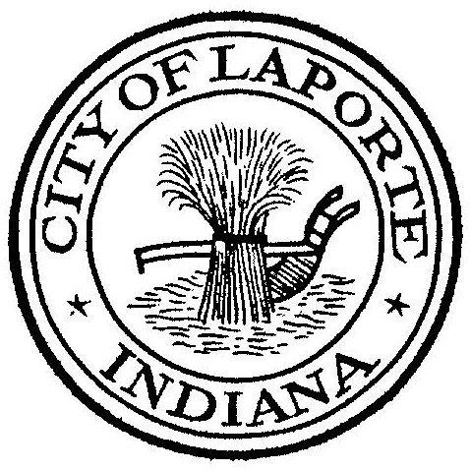
Board of Public Works and Safety
Jessica Romine, Member Tom Dermody, Mayor Mark Kosior, Member
City Hall 801 Michigan Ave., La Porte, IN 46350
Wednesday, February 23, 2022
9:00 AM
AGENDA
- Call To Order
- Pledge Of Allegiance
- Approval Of Minutes
- Public Comment: via Facebook Live
- Clerk-Treasurer: Claims Approval
- Swearing In Ceremony for new Police Officers
- Department Head Reports
- New Business:
-Parking Ticket Appeals: #62009/#61981/#61488
-Request For Signature: 4th of July Flyover Request
LPCYMCA Triathlon
LPCYMCA Tour de La Porte
-Uniform Conflict of Interest Disclosure Statement(s)
Tim Franke
-Nick Otis: Quit-Claim Deed for Habitat For Humanity
-Jen Noll: IPEP Grant Acceptance
-Craig Phillips: Tibma Bakery Development Agreement
Rezoning Application for 18th St Property
-Beth West: Amended Operating Assistance for Grant #1 and Grant #2
-Andy Snyder: Accept Retirement Letter and Authorize Replacement
-Jerry Jackson: Monroe Manor Construction Services
-Paul Brettin: Lease Proposal
-Nick Minich: Request to Re-Bid & Set Special BOW Meeting-2022 Paving
Purchase of Property-Atwood and Marshall
Payment for N=S Corridor MOU Invoice
Civic Phase 2 Improvements Amendment 1-Schneider Electric
8) Unfinished Business:
- Other Business:
10 Adjourn

